

**JOMO KENYATTA UNIVERSITY OF AGRICULTURE**

**AND TECHNOLOGY**

**DEPARTMENT OF ELECTRICAL AND ELECTRONIC ENGINEERING**

**BSc Electronic and Computer Engineering**

**PROJECT PROPOSAL ABSTRACT**

**PROJECT TITLE:**

**VOICE CONTROLLED ASSISTANT.**

**Submitted by:**

**MARK ODHIAMBO- ENE212-0154/2017**

**PROJECT SUPERVISOR**

**MR. ALOO**

*A Final Year Project Proposal submitted to the Department of Electrical and*

*Electronic Engineering in partial fulfillment of the requirements for the Award of a*

*Bachelor of Science Degree in Electronic Engineering.*

**JULY 2022**

**DECLARATION**

This project proposal is my original work, except where due acknowledgement is made in the text, and to the best of my knowledge has not been previously submitted to Jomo Kenyatta University of Agriculture and Technology or any other institution for the award of a degree or diploma.

**TITLE OF PROJECT:**

**VOICE CONTROLLED ASSISTANT**

**SUPERVISOR CONFIRMATION:**

This project proposal has been submitted to the Department of Electrical and Electronic Engineering, Jomo Kenyatta University of Agriculture and Technology, with my approval as the University supervisor:

**NAME OF SUPERVISOR………**MR. ALOO**………………**

**SIGNATURE: ……………………………… DATE: ……………………………………….**

**ABSTRACT**

Everyone who works has several tasks to do and sometimes can be overwhelming leading to burn out, stress and incomplete work. It is tedious to schedule, remember and manage a schedule especially when multiple tasks are involved it creates a tangled mess which can be frustrating. The aim of this project is to help solve this through a voice controlled assistant.

The voice controlled assistant is going to be used in scheduling, managing and setting reminders through voice commands. This will make work easier and ease the workload of an individual, through proper planning and management it aims to make people more productive and reduce stress.

This project will be implemented through the use of python programming for voice recognition and detection, and use of raspberry pi as the hardware for the project.

**TABLE OF CONTENTS**

ABSTRACT ii

1. INTRODUCTION. 1

1.2 Problem statement 3

1.3 Project justification. 3

1.4 Objectives 4

2. LITERATURE REVIEW 6

3. METHODOLOGY 17

4. EXPECTED RESULTS 28

**LIST OF FIGURES**

**LIST OF TABLES**

**CHAPTER ONE**

1. **INTRODUCTION.**
   1. **Background Information**

Task and schedule management has been a concern in numerous industries for years, including finance, health care, administration, and retail. In the current technological age, it is not only necessary to manage the existing tasks, but it is also important to boost productivity. This problem is faced with many people. Therefore, this project suggests that using a Voice controlled assistant can boost productivity in the workforce.

Scheduling tasks is one of the most important activities in today's fast based work environment. Productivity can be boosted with a well designed voice controlled assistant. The implementation of a voice controlled assistant will help a person to plan, schedule and manage tasks.

* 1. **Problem statement**

## People who work will always schedule, manage and plan their tasks. At some point, everyone will need to boot their productivity. A properly made schedule is critical and a poorly made one will end up causing harm, confusion and stress. The majority of either follow a timetable which is static and not ideal for a flexible work schedule. People require a platform that will enable them to be able to be more dynamic and allow them to be flexible in their planning. The voice controlled assistant aims to achieve this.

In reality, most people rarely understand the benefits of time management and proper planning and scheduling. We rely on a time table and setting appointments which can lead to conflict of different tasks at the same time and leading to misunderstandings , which is a sort of inconvenience. As a result, a lot of time is wasted that could be spent on more important activities. Implementing a voice controlled assistant would aid in this.

The proposed voice controlled assistant aims to improve creativity and help with time management. They won't have to spend as much time on setting appointments through different software or worse an analogue system of writing things down which can be misplaced or lost, when they could be doing something more productive.

* 1. **Justification.**

The project is significant because it will assist to schedule and set tasks through this will increase productivity with the use of a voice controlled assistant. Productivity is important because it will help one accomplish more tasks in less time and more efficiently. This will also help in reducing stress and making one more organized.

* 1. **Objectives**
     1. **Main objectives**

To design, implement and test a voice controlled assistant, with a real-time update of setting tasks and reminders to boost creativity..

* + 1. **Specific objectives**

1. To design and deploy an application.
2. To design and prototype an electronic system for voice detection, synthesize and processing so as to be able to query tasks.
3. To implement an electronic system for voice output.

**CHAPTER TWO**

**LITERATURE REVIEW.**

**Overview of Voice Controlled Assistant.**

Voice controlled assistants help reduce the manual efforts being put by humans in their task and schedule management of their day-to-day tasks. In this project, we develop a voice-controlled assistant. The human voice commands are given to the assistant remotely, by using an audio system. The assistant can manage several tasks such as setting appointments and a schedule. The voice commands are processed in real-time, using an online cloud server for example google. The speech signal commands converted to text form are communicated to an api the tasks are later logged and displayed on the app.

The personal assistant is developed on a microprocessor based platform. The effectiveness of the voice control communicated over a distance is measured through several experiments. Performance evaluation is carried out with encouraging results of the initial experiments. Possible improvements are also discussed towards more complex tasks.

**Current systems.**

The current voice controlled assistant systems are used for web scraping. An example of this is the google voice controlled assistant available to any phone that has the google installed. The assistant is run on the mobile device and its capability is used to search the web for information the user wants to ask about. There are several limitations to this system such as it only works as a browser and therefore not able to do other tasks such as task management.

There is also the famous alexa that is capable of doing many tasks on top of searching information from the web.It is capable of voice interaction, music playback, making to-do lists, setting alarms, streaming podcasts, playing audiobooks, and providing weather, traffic, sports, and other real-time information, such as news. Alexa can also control several smart devices using itself as a home automation system. The disadvantage of this system is that it is not available or widely spread in african countries and third world countries for example kenya.

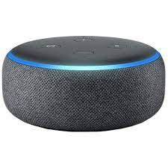

Another form of voice systems is the voice recognition that uses the pattern recognition for security purposes as an access controlled feature. This is able to allow specific people to get access to a certain system and controls the amount of people who have access to it.

**Proposed systems.**

The voice controlled assistant that is to be developed in this project is a voice controlled assistant with the ability of transcribing information and querying tasks for the tasks schedule and project management.

The voice controlled assistant should be able to display the tasks set on an application so that the user can be able to have a visual display of the tasks on the application; this is a unique feature of the project.

**Software development.**

This is the review of the software selection of the project and the reason for selecting the software.

**Python.**

In the project the microprocessor will run on the platform through the use of the Python language. Python is a high-level, interpreted, general-purpose programming language. Its design philosophy emphasizes code readability with the use of significant indentation. Python is dynamically-typed and garbage-collected.

The reason for choosing python is that's it has a long history therefore there would be libraries available for sound processing and making an API for the application.



**React.**

The react will be used for the front-end and will enable the information to be updated in real-time onto the person’s device as the voice commands are issued. This is the open source javascript library that is used for building the user interface.

**API.(Application Programmable Interface)**

API is the acronym for Application Programming Interface, which is a software intermediary that allows two applications to talk to each other. Each time you use an app like Facebook, send an instant message, or check the weather on your phone, you’re using an API.

When you use an application on your mobile phone, the application connects to the Internet and sends data to a server. The server then retrieves that data, interprets it, performs the necessary actions and sends it back to your phone. The application then interprets that data and presents you with the information you wanted in a readable way. This is what an API is - all of this happens via API.

**Hardware development.**

**Microprocessor.**

A microprocessor is a computer processor where the data processing logic and control is included on a single integrated circuit, or a small number of integrated circuits. The microprocessor contains the arithmetic, logic, and control circuitry required to perform the functions of a computer's central processing unit.

**Raspberry pi.**

Raspberry Pi is a series of small single-board computers developed in the United Kingdom by the Raspberry Pi Foundation in association with Broadcom. The Raspberry Pi project originally leaned towards the promotion of teaching basic computer science in schools and in developing countries. Currently raspberry pi is used in small prototyping projects due its advantages and cost.

Raspberry pi was used as the microprocessor because several important features were used for the input. This is for example its ability to have a higher computation power that would be useful to the process of the voice command and factoring that there will be also other components such as the speaker and the microphone.

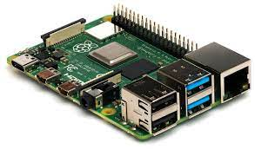

**Speakers.**

This is a device that is responsible for the conversion of the electrical energy into a sound energy. The speaker for this system is used so that the computer will be able to communicate information and queries to the user.

**METHODOLOGY**

**Software development.**

**Application development**

This is tied to the objective number one; to design and implement an application. The type of methodology that will be employed in the creation of the Schedule management platform will be defined in this chapter. The prototype model is the methodology model that will be used in the design and deployment of the application.

React native would be used so that one can access the information from the phones of their which is a more accessible device.

**Python.**

This programming language will be used to process the voice commands from the Rasberry pi speaker. The libraries required for this application is:

* Flask/ Django
* Pyaudio

The project has been designated crystal therefore that is the word required to activate it and open it. The implementation of the system is detailed in the block diagram; there will be a speaker that takes in the input. It will process the input and depending on the different situations respond in different manners to allow one to set a task, reminder or alarm.

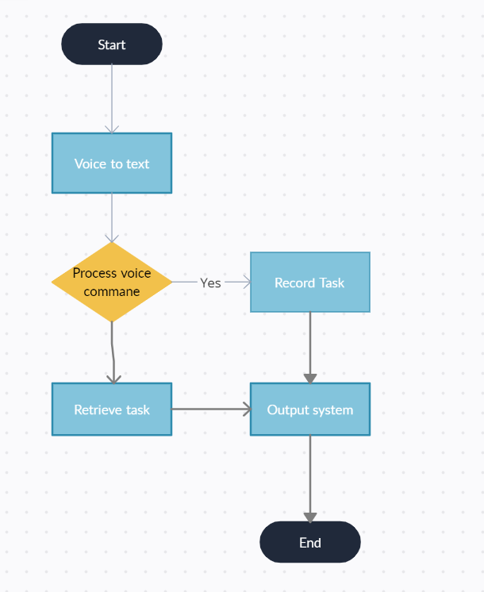

**Hardware development.**

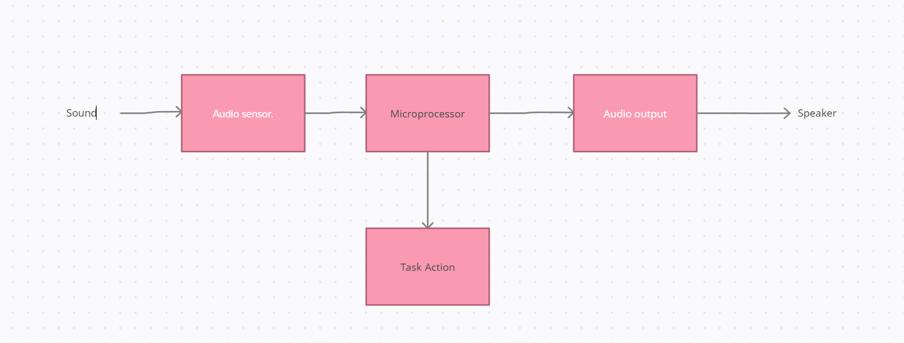

**Components of the Voice controlled assistant.**

Considering the necessary requirements, the chosen solution to build the voice controlled assistant will be based on the following components.

* Speaker
* Microphone
* Microprocessor

**CHAPTER FOUR**

**EXPECTED RESULTS**

I hope that the project I am working would be of great help to the user in planning and the setting of tasks and to aid in the increasing of productivity.

**TIME-PLAN**

| **ACTIVITIES** | **MAY** | **JUNE** | **JULY** | **AUG** | **SEP** | **OCT** | **NOV** | **DEC** |
| --- | --- | --- | --- | --- | --- | --- | --- | --- |
| **Documentation** |  |  |  |  |  |  |  |  |
| **Proposal Writing** |  |  |  |  |  |  |  |  |
| **Literature Review** |  |  |  |  |  |  |  |  |
| **Proposal Presentation** |  |  |  |  |  |  |  |  |
| **Design and coding** |  |  |  |  |  |  |  |  |
| **Hardware** configuration**, testing and adjustment** |  |  |  |  |  |  |  |  |
| **Final Report writing** |  |  |  |  |  |  |  |  |
| **Final Presentation** |  |  |  |  |  |  |  |  |

**REFERENCES**